Supply chain
Destiny Ruiz
Grand Canyon University
10/16/2018

Create a flowchart of the original supply chain
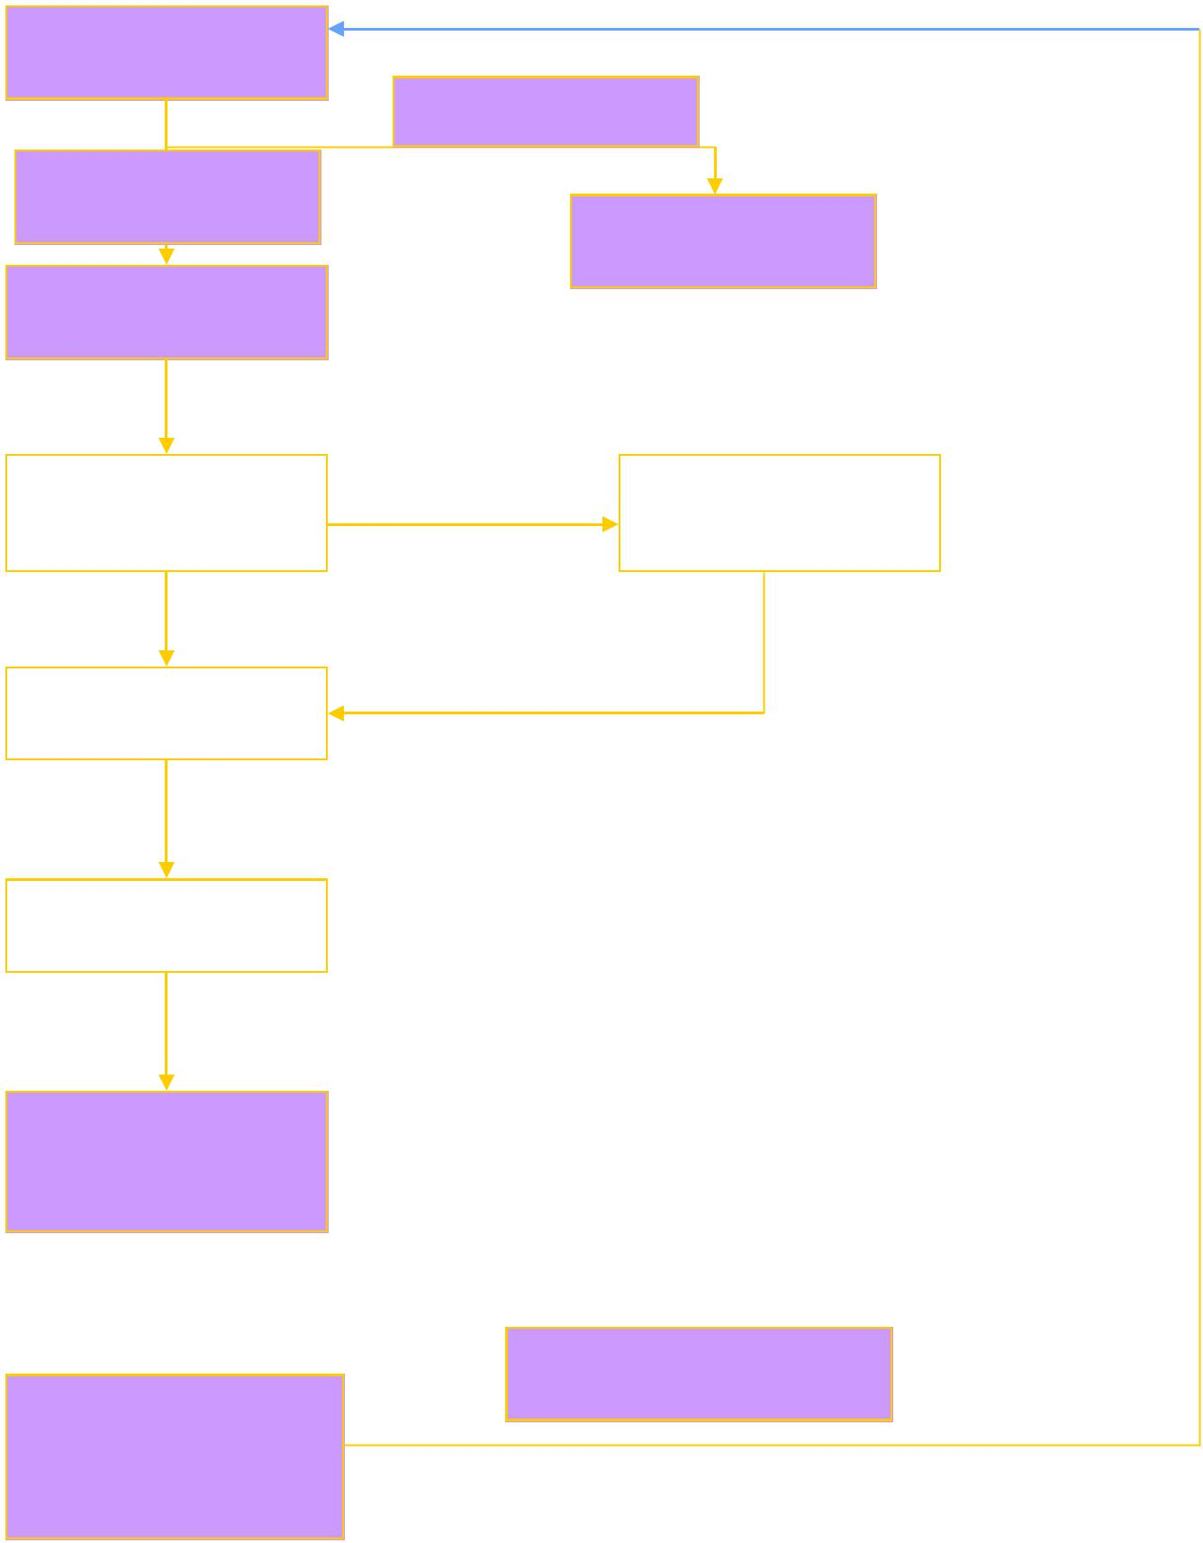
No capital
Product Ordering
Capital available
Product Purchase
Chain end

Product control
The grill chains in the hotel

Product Input

Storage of the raw material

Production/manufacturing

Repeat the process
Service to the customer or the end user

Commentary
Chipotle input supplies in this case do not bother about the quality of the chain which leaves the quality of products supplied at stake. The chain lacks a system that monitors the quality standard of the products and this might be a gap leading to contamination. A good example is when the restaurant works with a pork supplier who is not reliable. At this point, the restaurant needs a reliable supplier who meets the need of the buyer. Due to the outbreak of E.coli, quality control is important. The supply chain should look for quality vendors who observe the quality standards and are reliable. One way to avoid complicating the supply is by looking for few suppliers who are reliable and who are keen on food safety.

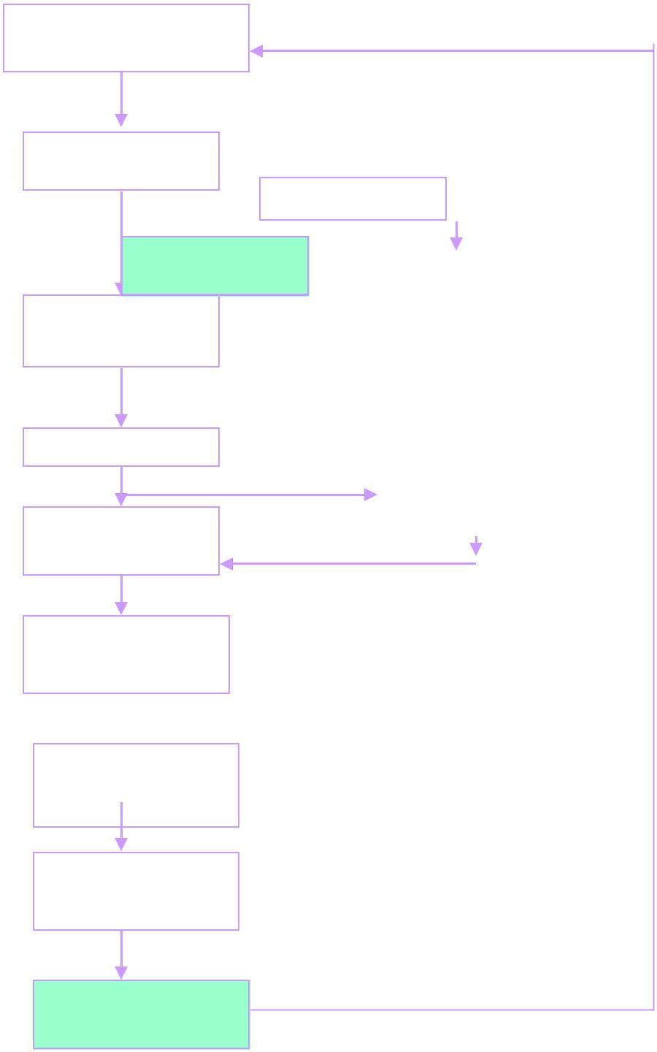
Review the supplier’s products

Procure the produce
No capital
Capital available
Monitoring and inspection
Chain end

Purchase/delivery
Supply to hotels/chains
Storage at the main warehouse/store
Quality control check

Restaurant production

Service to the consumer

Measurement of performance

Commentary
After evaluating Chipotle’s supply chain, there is need for correction in order to ensure the chain maintain quality for goods procured. Chipotle restaurant need to introduce a centralized procurement system that will allow scrutiny and inspection of goods once they enter the central store. On the other hand, the vendors ought to be qualified to supply to the restaurant. The restaurant ought to check their standards, the financial strength, and their ability to supply large volumes of input required. This will eliminate the large numbers of vendors who put the quality of the products at risk. After delivering its products, there is need for Chipotle to look for customer views or feedback about the quality of the products and seek measures that will consciously improve on the quality of the products, safety etc. The chart a has put the concerns mentioned in the original supply chain and made a number of improvements that will help build a quality supply chain

McDonald’s restaurant chain
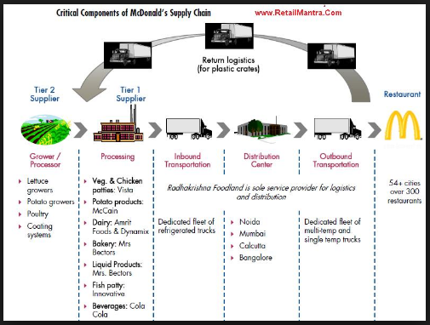
How to improve MacDonald’s supply chain
Macdonald’s supply chain lacks major quality control checks that are key in testing whether the produce from the growers meets the set standards. The supply chain should also include quality storage for the products maybe in a cold room in order for the produce to remain fresh. Quality checks will help the company gain competitive advantage for top quality food services.
The six-sigma methodology implementation procedure for a proper supply chain was used to reach a conclusion of the needs of the supply chain in order to achieve maximum quality in products delivered.
- Recognition
The company needs to identify the market opportunities, which are based on the set strategic goals
- Define
The methodology proceeds to define a right way to implement the plan in order for it to be successful
- Measure
The six sigma methodology measures and summarizes baseline data
- Analyze
The company’s management is able to study the current process in order to identify the causes of variations in the critical-to-quality characteristics
- Improve
The six sigma helps in identifying the best configuration that is necessary for the plan.
- Control
Control plans are key in the implementation of the project and sustain improvements
- Sustain
A the company manager, I am able to response to plans and updates when there is new information available
- Institutionalize
Change is essential in order to support the ongoing improvements in the company (Aruleswaran, 2014).
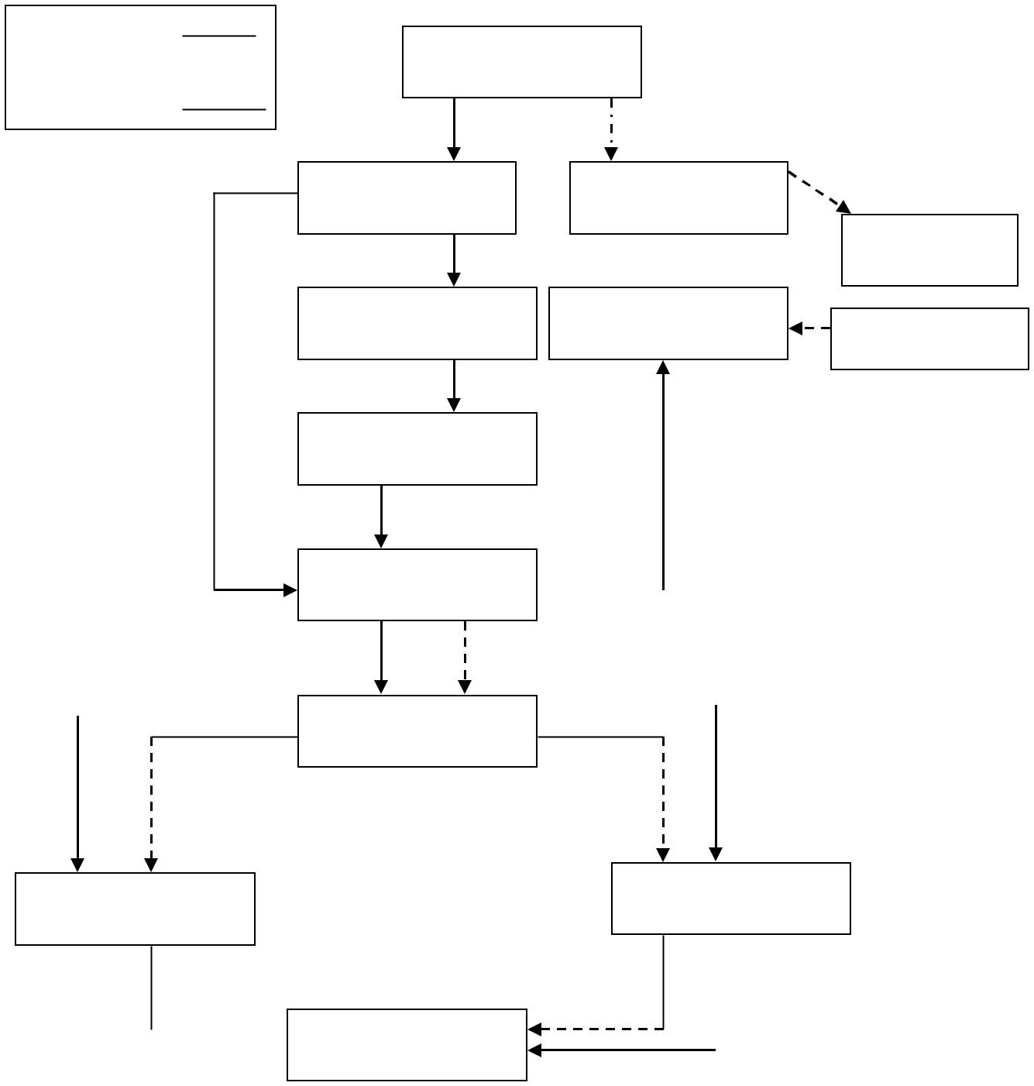
The following supply chain chart has included a number of recommendations in the system such as quality control and value adding such as branding.
Raw agricultural commodity
Field production

Harvest
Field control
Retail/food service
Cooling
Value added processing
Inspection/QC
Transportation
Cold storage rooms

Transportation

Retail/ food service
Food service outlet

Consumer

References
Aruleswaran, A. (2014). Changing with Lean Six Sigma. Selangor, Malaysia: LSS Academy Sdn. Bhd.
Bourlakis, M. A., & Weightman, P. W. H. (2018). Food Supply Chain Management. Hoboken: Wiley.
Dani, S. (2015). Food supply chain management and logistics: From farm to fork. London: Kogan Page.
Vitasek, K., Manrodt, K., & Kling, J. (2012). Vested: How P & G, McDonald's and Microsoft are Redefining Winning in Business Relationships. New York: Palgrave Macmillan.
https://www.bloomberg.com/features/2015-chipotle-food-safety-crisis/

